**Lab#6(a) Using design of lab 3:**

**a. Implement a category and product management page with insert, update and delete operations.**

**and delete operations.**

|  |  |  |
| --- | --- | --- |
| **TAGS USED** | **ATTRIBUTES USED** | **DESCRIPTION** |
| <HTML> | -- | Define that how web browser will format and display the content. |
| <HEAD> | -- | It is used to contain information of the document. |
| <TITLE> | -- | Display the title of webpage. |
| <LINK> | Rel, href | Link External CSS |
| <BODY> | Background | Display the content of webpage |
| <H3> | Align | Define the Heading according  H3 style |
| <Form> | -- | It is use to create html for user input. |
| <Div> | class | It is for display the content section wise. |
| <input> | Type | It is use to declare input controls. |
| <img> | Src, class | Display the particular image. |
| <BR> (Break Line) | -- |  |
| <Button> | Class, Type | It is use to clickable function. |

**Final Outcome:**

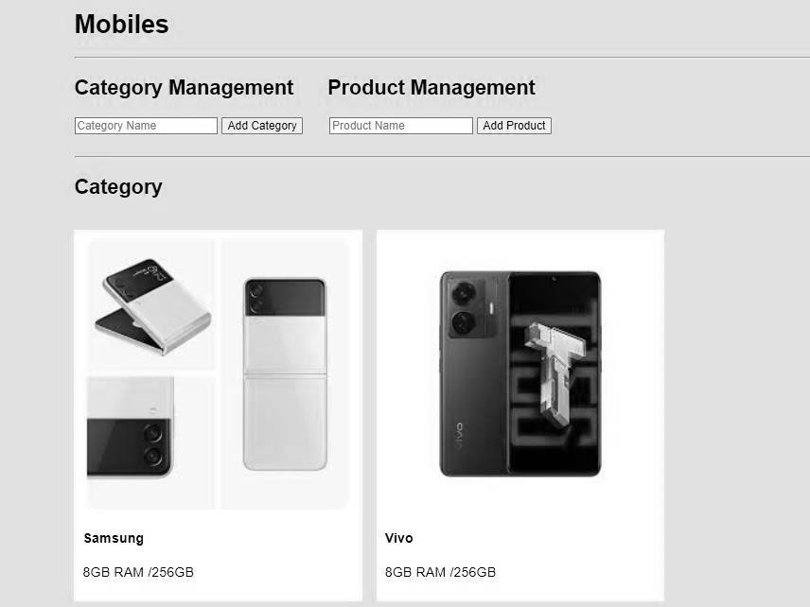

**Code Snippet:**

<!DOCTYPE html>

<html>

<head>

<meta name="viewport" content="width=device-width, initial-scale=1">

<style>

{

box-sizing: border-box;

}

body { background-color:bisque;

padding: 20px;

font-family: Arial;

}

.main { max-width: 1000px;

margin: auto

} h1

{

fontsize: 30px;

wordbreak: break-

all;

}

.row {

margin: 10px -16px;

}

.row,

.row > .column {

padding: 8px;

}

.column {

float: left;

width: 33.33%;

display: none;

}

.row:after { content: ""; display: table;

clear: both;

}

.content {

background-color: white;

padding: 10px;

}

.show { display: block;

}

</style>

</head>

<body>

<div class="main">

<h1>Mobiles</h1>

<hr>

<h2>Category Management &nbsp;&nbsp;&nbsp;&nbsp;&nbsp;Product Management</h2> <form id="category-form">

<input type="text" id="category-name" placeholder="Category Name" required>

<button type="submit">Add Category</button>

&nbsp;&nbsp;&nbsp;&nbsp;&nbsp;

<input type="text" id="product-name" placeholder="Product Name" required>

<button type="submit">Add Product</button>

</form> &nbsp; <hr>

<h2>Category</h2>

<div class="row">

<div class="column nature">

<div class="content">

<img src="samsung1.jpg" alt="Mountains" style="width:100%">

<h4>Samsung</h4>

<p>8GB RAM /256GB </p>

</div>

</div>

<div class="column nature">

<div class="content">

<img src="Vivo2.jpg" alt="Lights" style="width:100%">

<h4>Vivo</h4>

<p>8GB RAM /256GB</p>

</div>

</div>

</div>

</div>

</body>

</html>

**Lab#6(b) Display products on home page from DB to all users.**

|  |  |  |
| --- | --- | --- |
| **Type Used** | **Attribute Used** | **DESCRIPTION** |
| <?php | If, else, die | It is use for opening php. |
| $_SERVER  [‘REQUEST_METHOD’] | -- | It is use for request the current script. |
| Die | $conn | It is use for immediate terminate the execution of the script. |
| $conn | mysqli, connect_error | It is use for connection purpose and establish the connection. |
| post | -- | It is use for sending the data to the server. |
| $stmt | Close() | It is use for representing the prepared statement object. |
| Insert | -- | It is use for inserting the value into the particular table. |
| Prepare | -- | It is use for creating the prepared statement. |
| Bind_param | -- | It is use for binding the variables to the placeholders in prepared statement. |
| Echo | -- | It is use for display the content. |
| ?> | -- | It is use for php ending tag. |

**Final Outcome:**

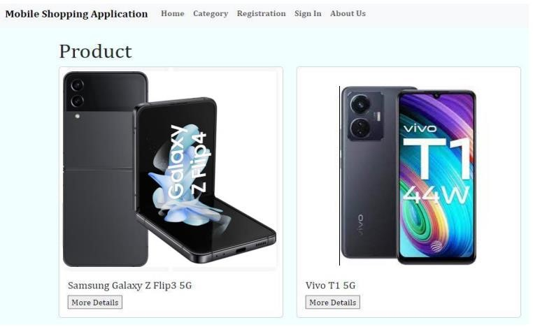

**Code Snippet:**

const { new } = require('nw'); const new = new new({

name: "root", host: "localhost", database: "products", password: "",

});

module.exports = new; const express = require('express'); const app = express(); const new = require('./db'); const PORT = process.env.PORT || 3000;

app.get('/api/products', async (req, res) => {

try {

const { rows } = await new.query('SELECT * FROM products');

res.json(rows); } catch (error) { console.error(error);

res.status(500).json({ message: 'Error fetching products' });

}

});

app.listen(PORT, () => { console.log(`Server is running ${PORT}`);

});

async function fetchProducts() { const response = await fetch('/api/products'); const products = await response.json();

const productsDiv = document.getElementById('products'); products.forEach(product => { const productElement = document.createElement('div'); productElement.innerHTML = ` <h2>${product.name}</h2> <p>Price:

$${product.price}</p>`; productsDiv.appendChild(productElement);

});

}

fetchProducts();

**Lab#6(c) If user is logged in then show “more details” on each product and show** **detailed product description if user clicks “more details.”**

|  |  |  |
| --- | --- | --- |
| **TAGS USED** | **ATTRIBUTES USED** | **DESCRIPTION** |
| <HTML> | -- | Define that how web browser will format and display the content. |
| <HEAD> | -- | It is used to contain information of the document. |
| <TITLE> | -- | Display the title of webpage. |
| <LINK> | Rel, href | Link External CSS |
| <BODY> | Background | Display the content of webpage |
| <H3> | Align | Define the Heading according  H3 style |
| <Form> | -- | It is use to create html for user input. |
| <Div> | class | It is for display the content section wise. |
| <input> | Type | It is use to declare input controls. |
| <img> | Src, class | Display the particular image. |
| <BR> (Break Line) | -- |  |
| <Button> | Class, Type | It is use to clickable function. |

**Final Outcome:**

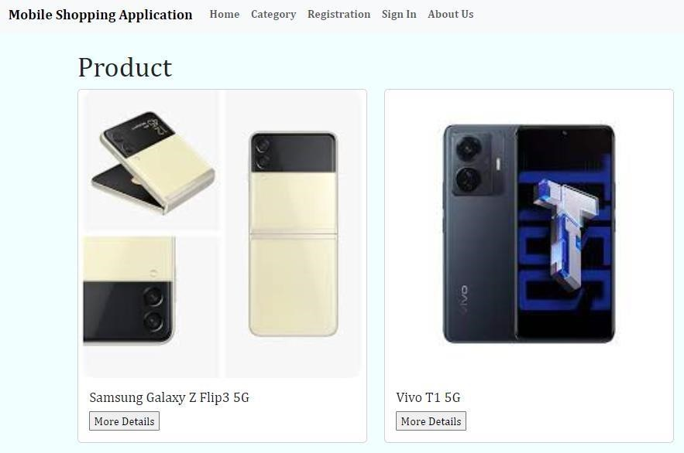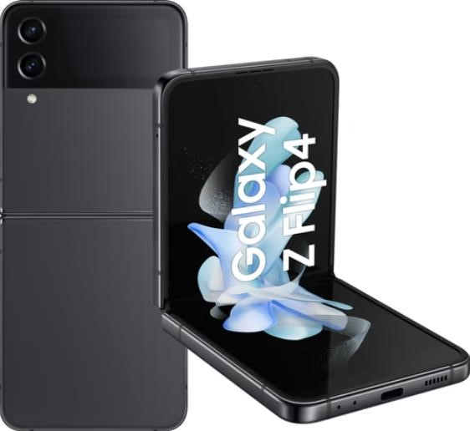

**Code Snippet:**

<!DOCTYPE html>

<html>

<head>

<title>Mobile Shopping Application</title>

<link href="https://cdn.jsdelivr.net/npm/bootstrap@5.3.0-alpha1/dist/css/bootstrap.min.css" rel="stylesheet">

<style>

body

{

font-family:Cambria, Cochin, Georgia, Times, 'Times New Roman', serif;

background-color: azure; font-weight: bold;

}

div collapse navbar-collapse{ background-

color: darkgray;

}

</style>

</head>

<body>

<nav class="navbar navbar-expand-lg navbar-light bg-light">

<div class="container-fluid">

<a class="navbar-brand" href="#">Mobile Shopping Application</a> <button class="navbar-toggler" type="button" data-bs-toggle="collapse" data- bs target="#navbarNav" aria-controls="navbarNav" aria-expanded="false" aria-label="Toggle

navigation">

<span class="navbar-toggler-icon"></span>

</button>

<div class="collapse navbar-collapse" id="navbarNav">

<ul class="navbar-nav">

<li class="nav-item">

<a class="nav-link" href="index1.html">Home</a>

</li>

<li class="nav-item">

<a class="nav-link" href="categories.html">Category</a>

</li>

<li class="nav-item">

<a class="nav-link" href="user_reg.html">Registration</a>

</li>

<li class="nav-item">

<a class="nav-link" href="login.html">Sign In</a>

</li>

<li class="nav-item">

<a class="nav-link" href="#">About Us</a>

</li>

</ul>

</div>

</div>

</nav>

<div class="container mt-4">

<h1>Product</h1>

<div class="row">

<div class="col-md-4 mb-4">

<div class="card">

<img src="samsung1.jpg" class="card-img-top" alt="Product 1">

<div class="card-body">

<h5 class="card-title">Samsung Galaxy Z Flip3 5G</h5>

<p class="card-text">Samsung Galaxy Z Flip3 5G ,Cream,8GB,<br>256GB Storage</p>

<div>Price: ₹89,000 &nbsp;&nbsp; <a href="#" class="btn btn-primary">Buy Now</a> </div> </div>

</div>

</div>

<div class="col-md-4 mb-4">

<div class="card">

<img src="Vivo2.jpg" class="card-img-top" alt="Product 2">

<div class="card-body">

<h5 class="card-title">Vivo T1 5G</h5>

<p class="card-text">Vivo T1 5G,Dark Blue,8GB,<br>256 GB Storage</p>

<div>Price: ₹17,000 &nbsp;&nbsp; <a href="#" class="btn btn-primary">Buy Now</a> </div>

</div>

</div>

</div>

</div>

</div>

</body>

</html>